Name: Humza Ahmed
ID: 15841
Program: BSCS
Course: Virtualization And Cloud Computing
Faculty: Faraz Abdul Basit

To create an account in any service provider like AWS, Azure etc and upload any file while creating it a public domain.

Webpage Link:
https://boisterous-nasturtium-d22ec1.netlify.app/

Netlify is a platform for building and deploying web projects.
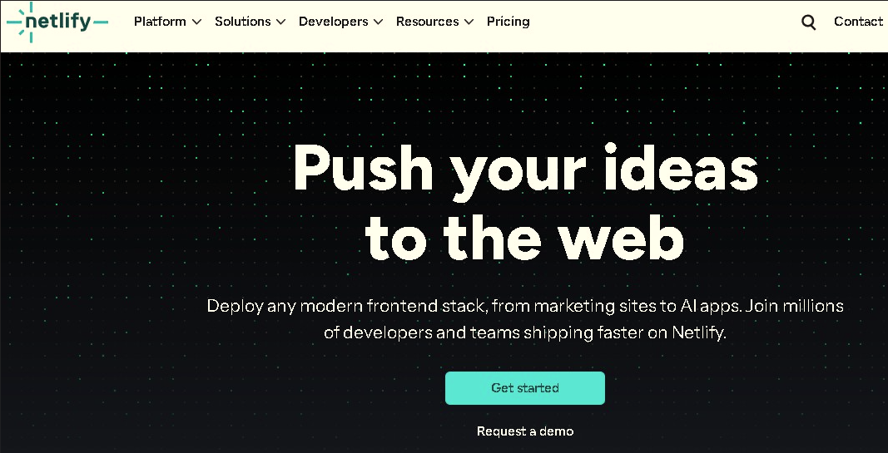

This is a Netlify login page. You can log in using:
- Google
- GitHub
- GitLab
- Bitbucket
- Email
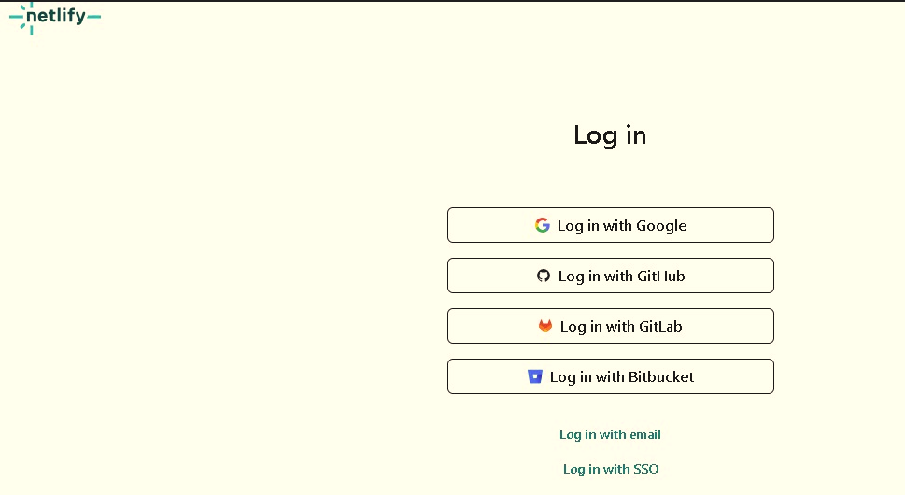

We also got the option to deploy the frontend to Netlify.
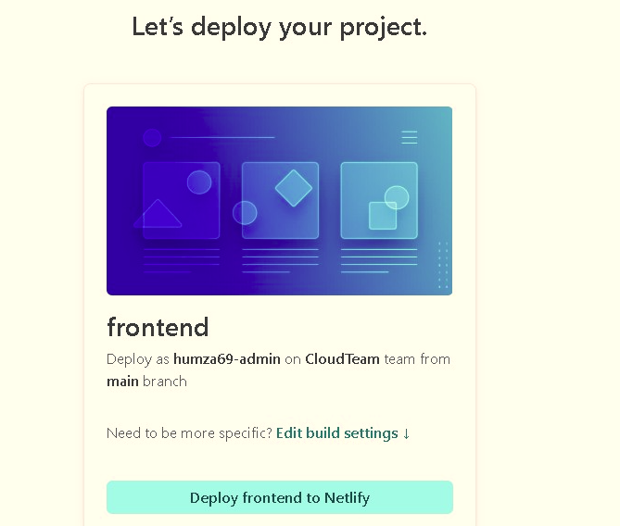

we have creating a repository named.
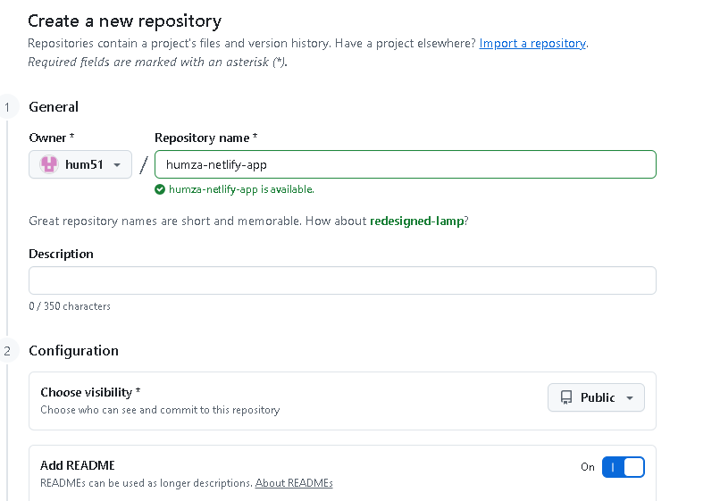

A test build,deploy and set up a custom domain.
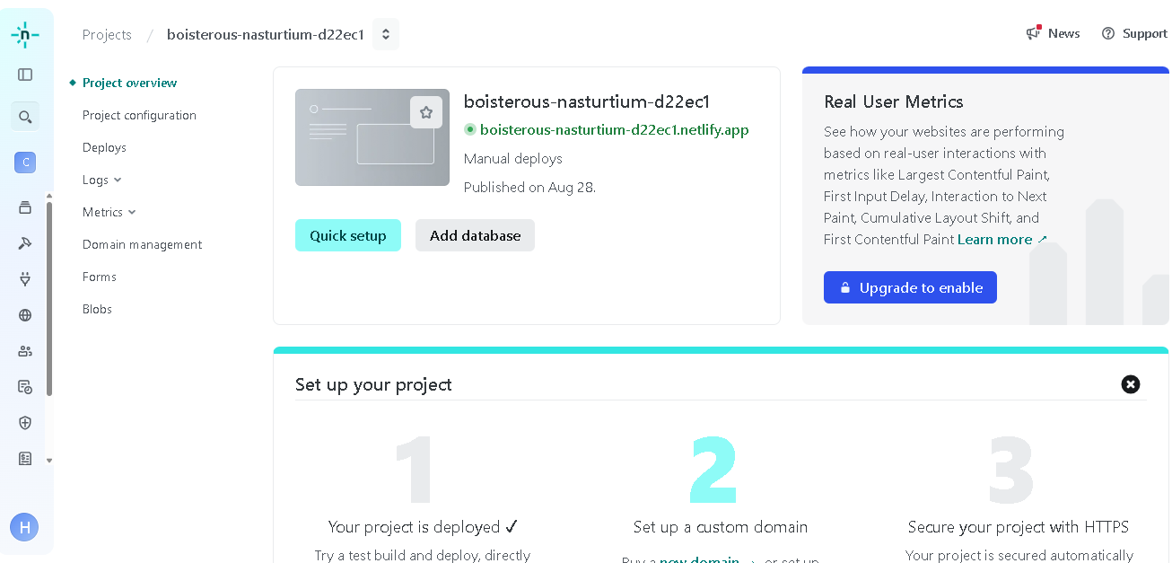
Calculate with the following inputs :
- Height: 6.5
- Weight: 57
